In This Document we Imported Live PMMDISOCVERER EUL INTO Local Oracle 11G database User(localdisco) and through Admin tool . Need to Compare DB Objects b/w New & old User and if anything missed need to import into new user Manaully.

1. Connect to new databse by from Discoverer Admin Tool

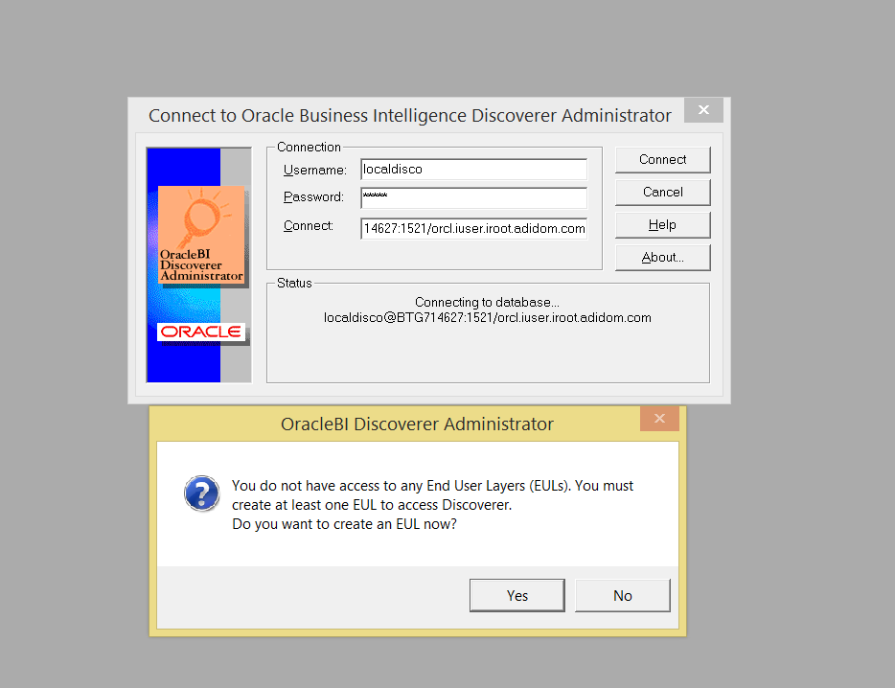

1. Click on Yes to Create EUL

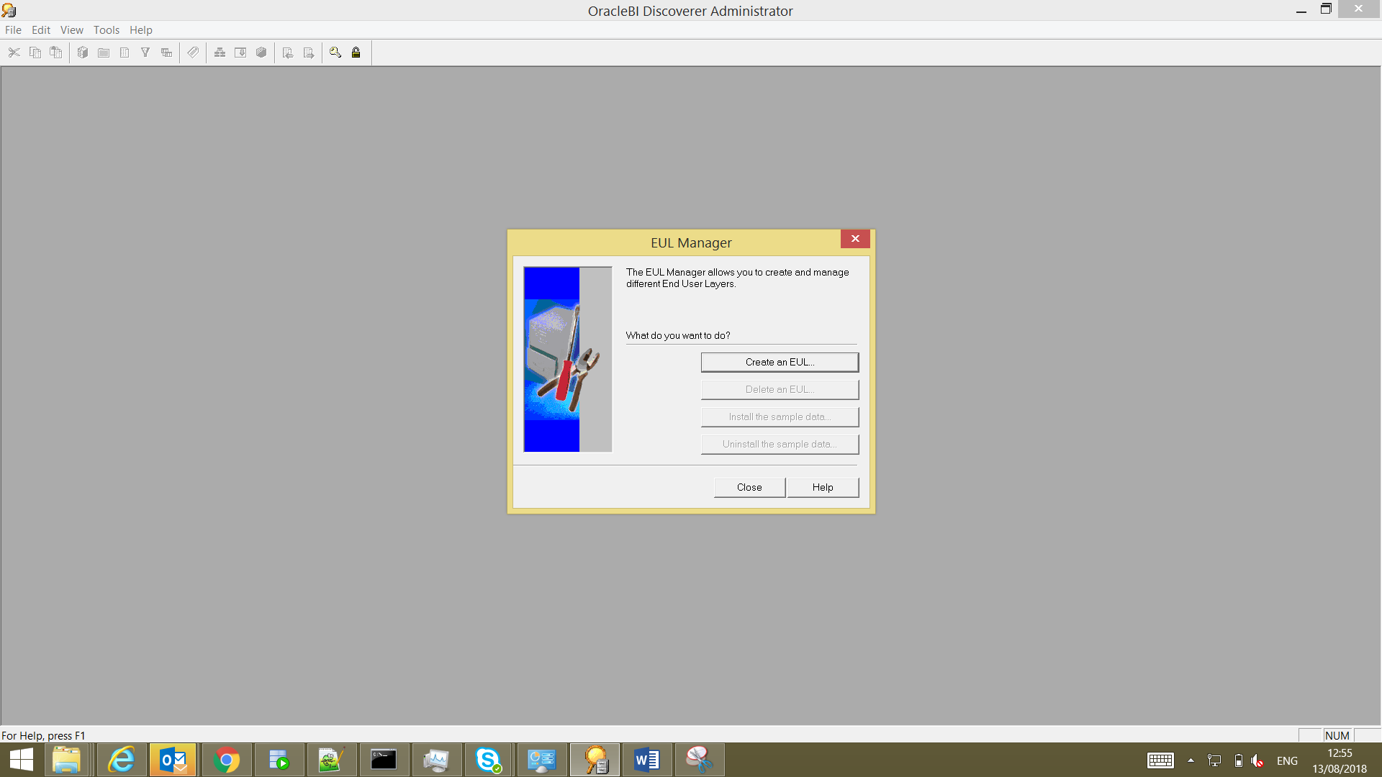

1. Click on Select User and Select new Discoverer user in new database

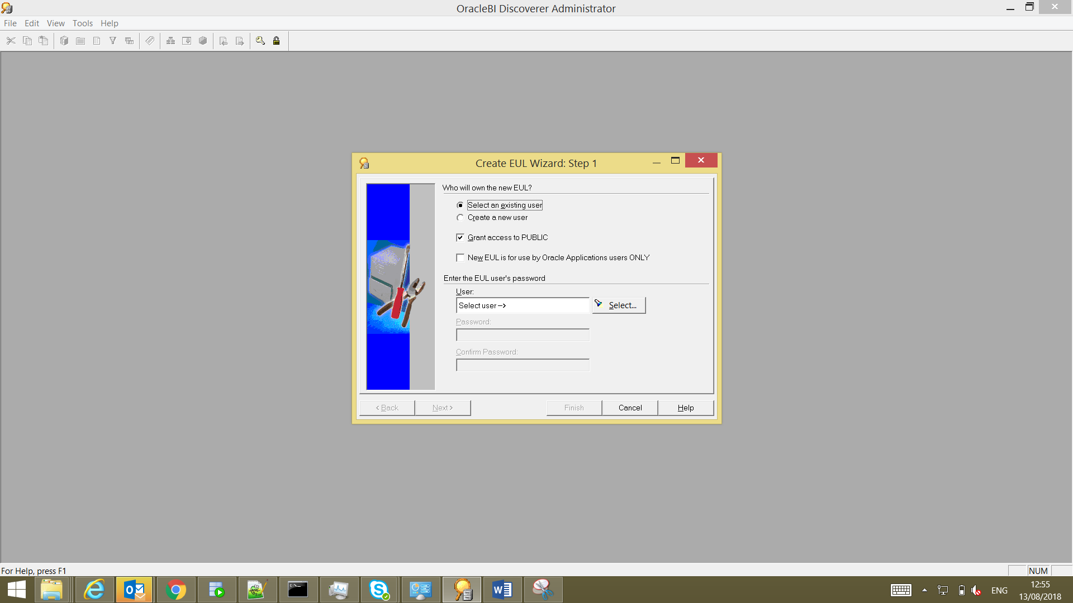

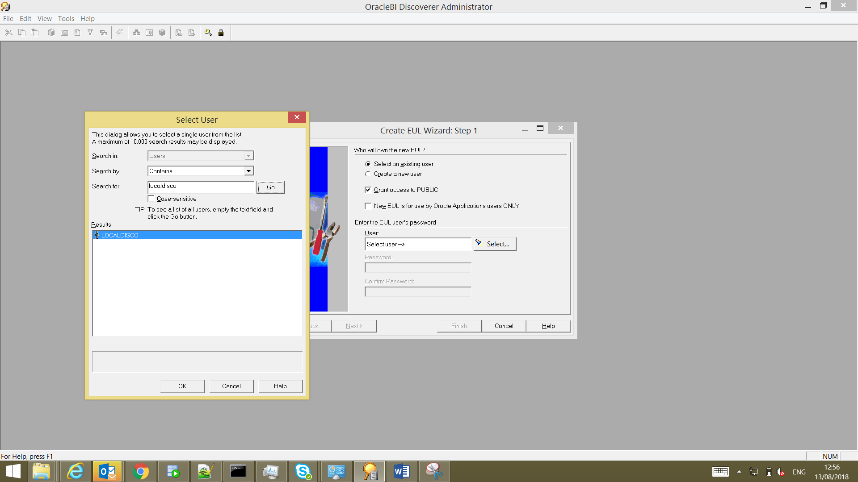

1. Click on Finish then EUL creation will be start

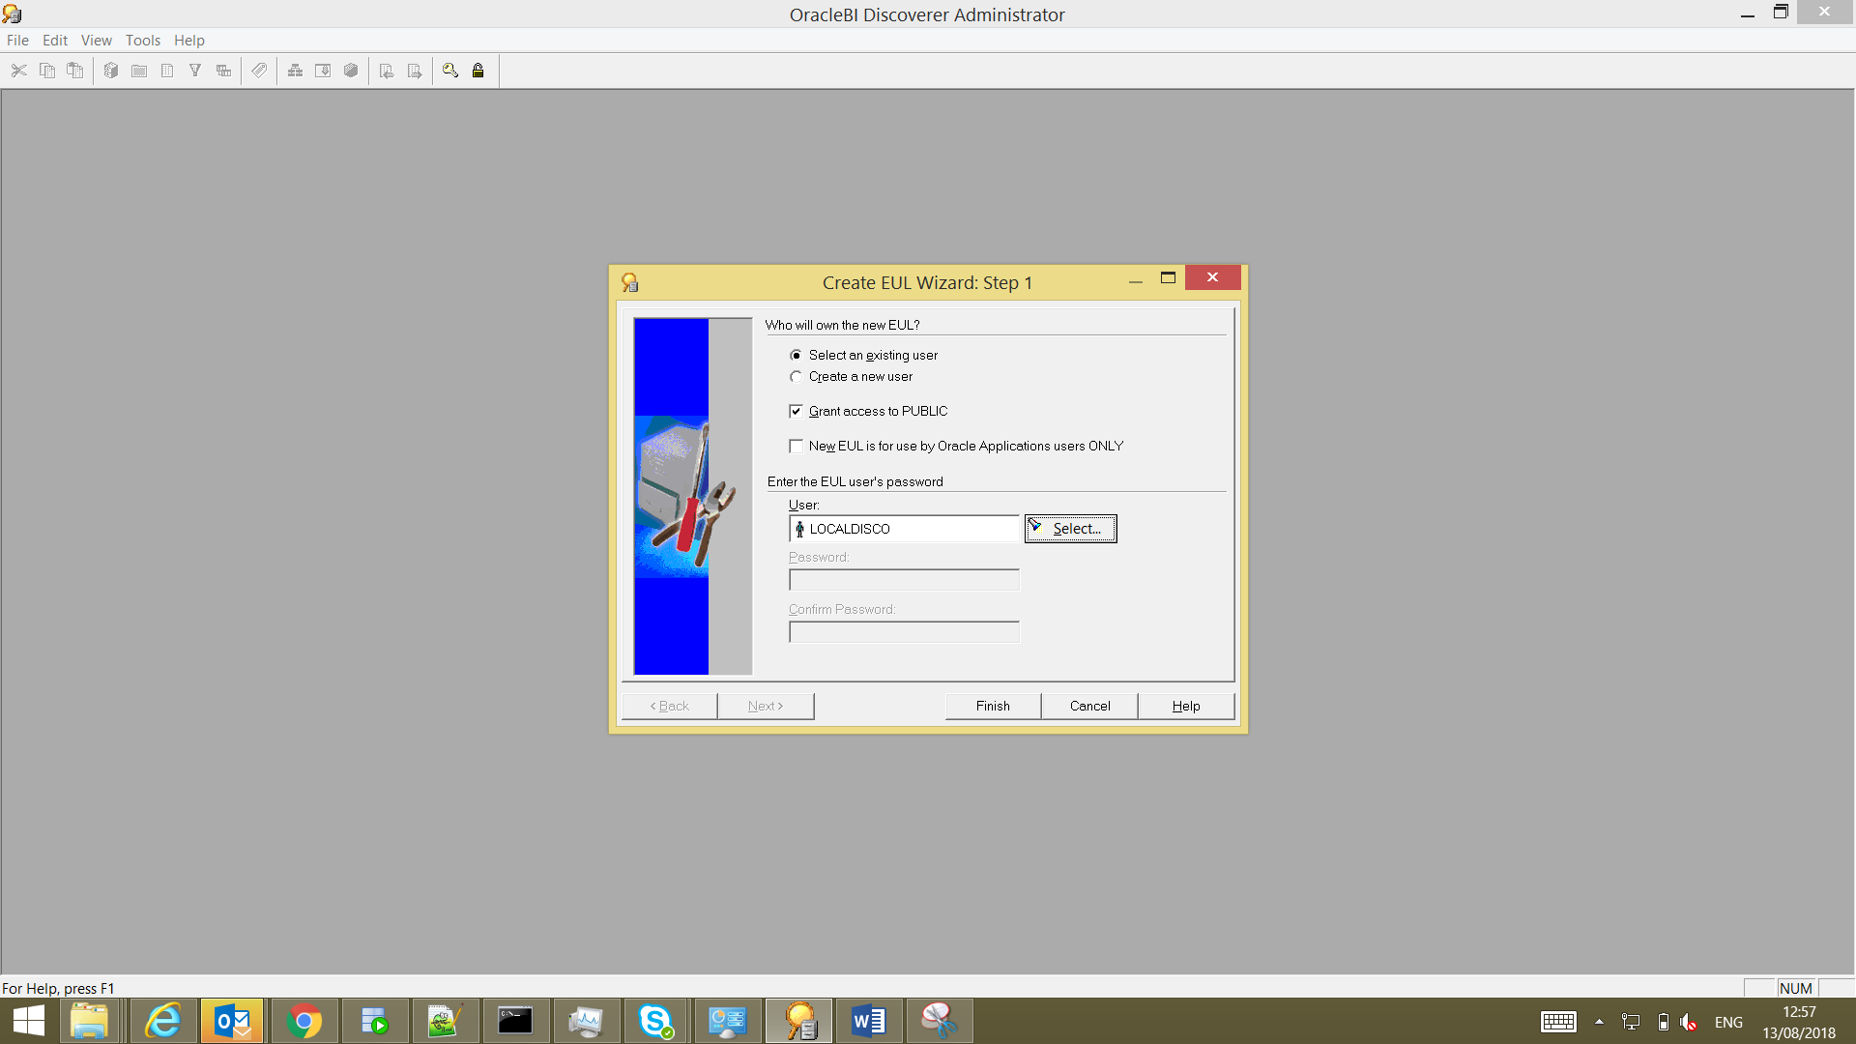

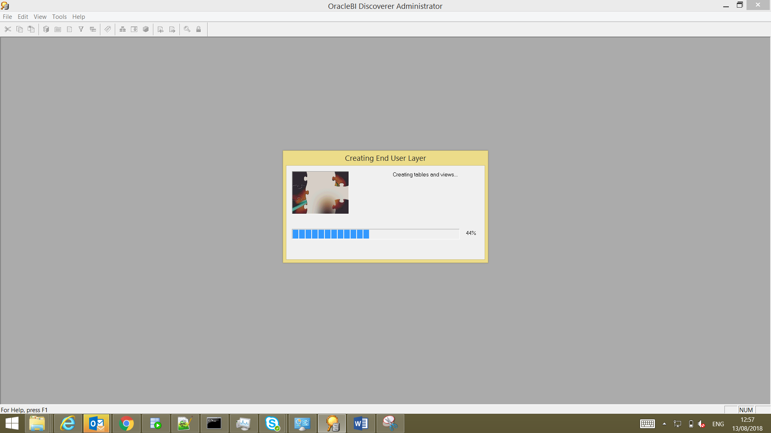

1. After EUL creation you can see success message like below image

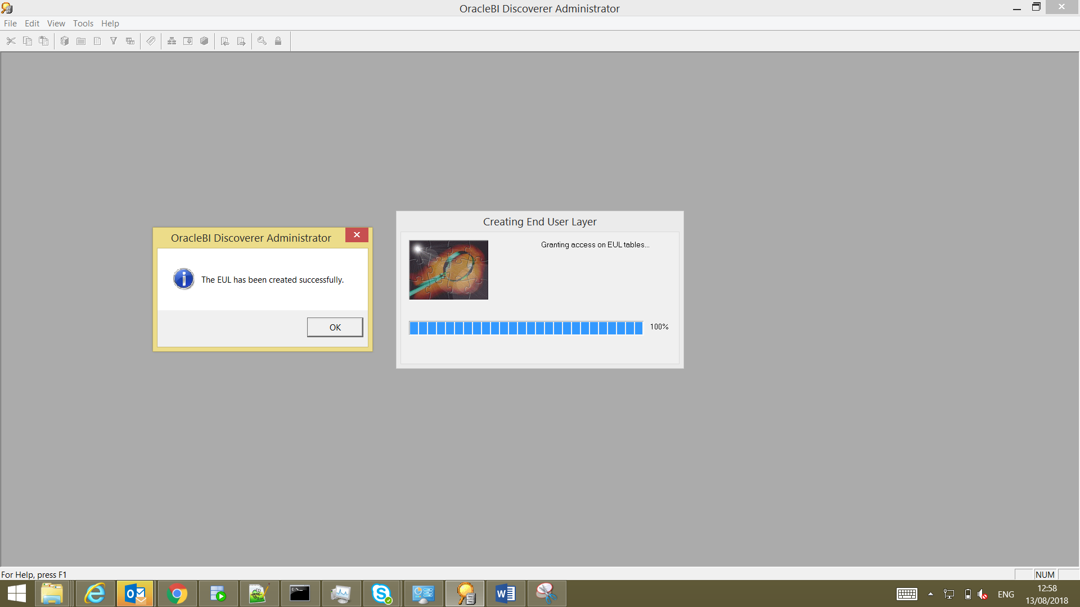

1. . Select as No and click on close

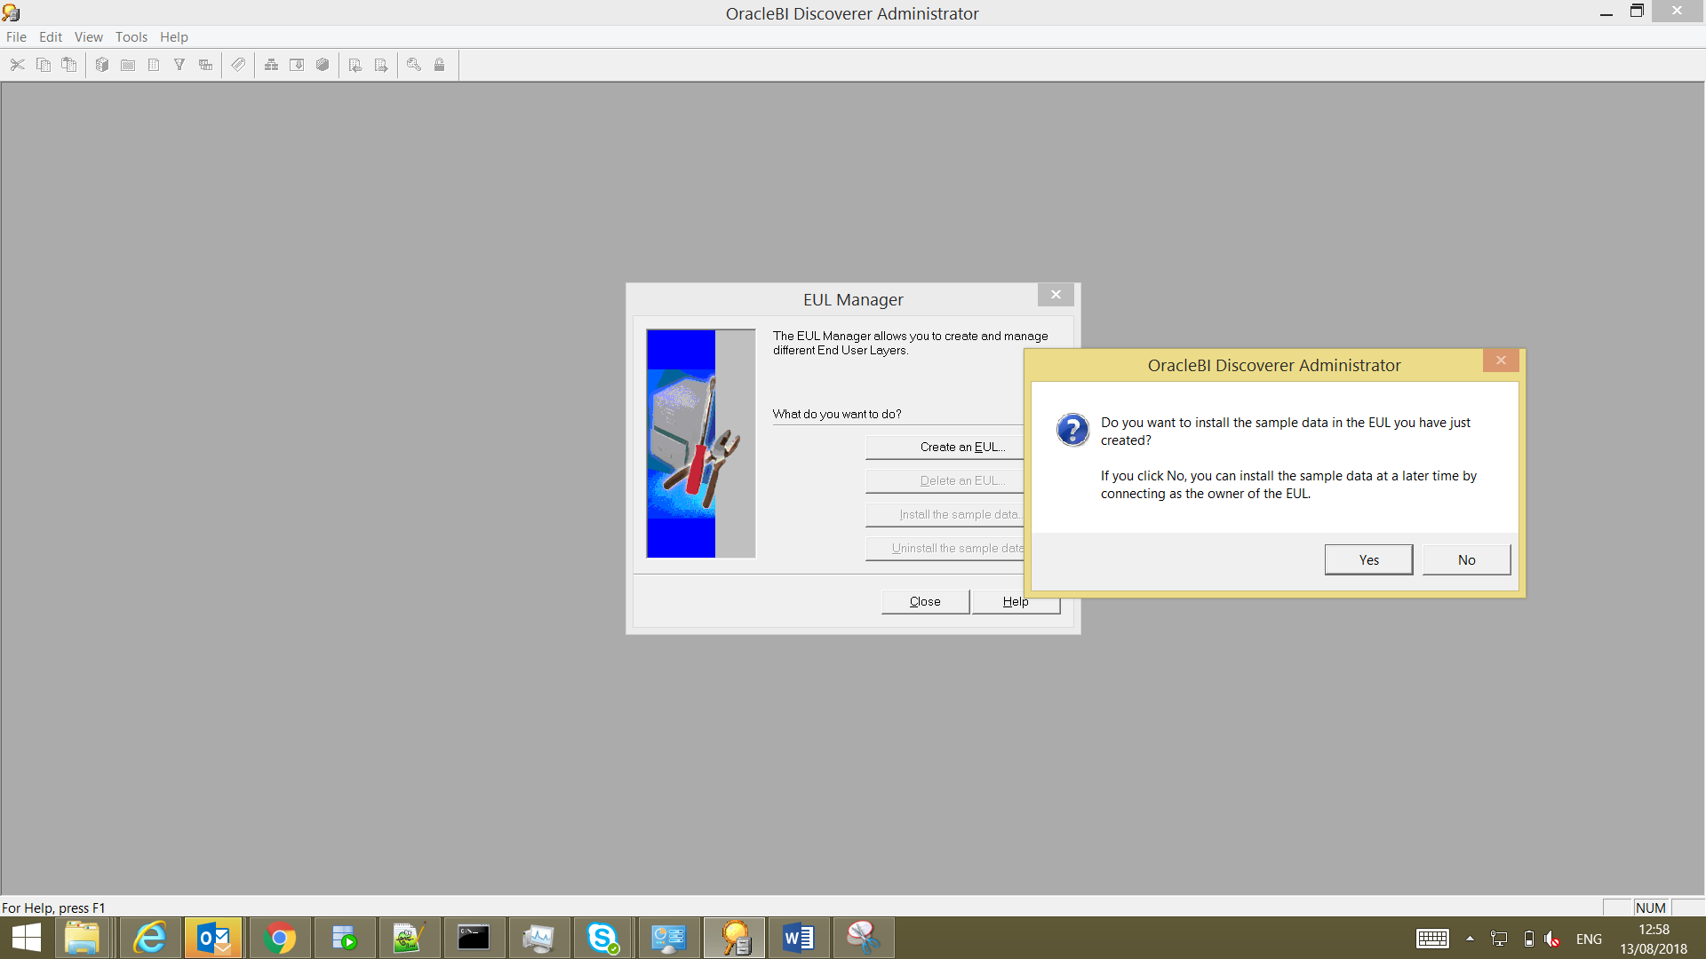

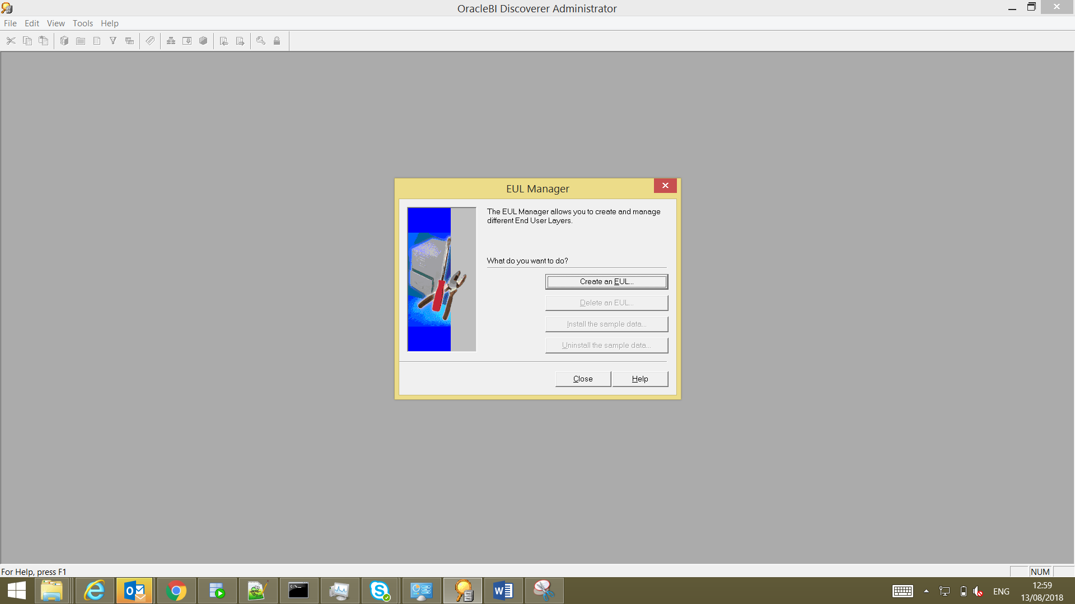

1. For importing EUL (.eex file ) into new user follow below steps. Click on File ->Import->Select File

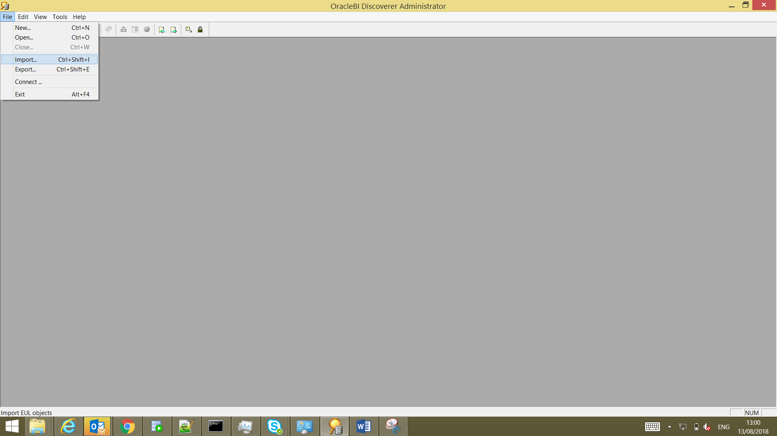

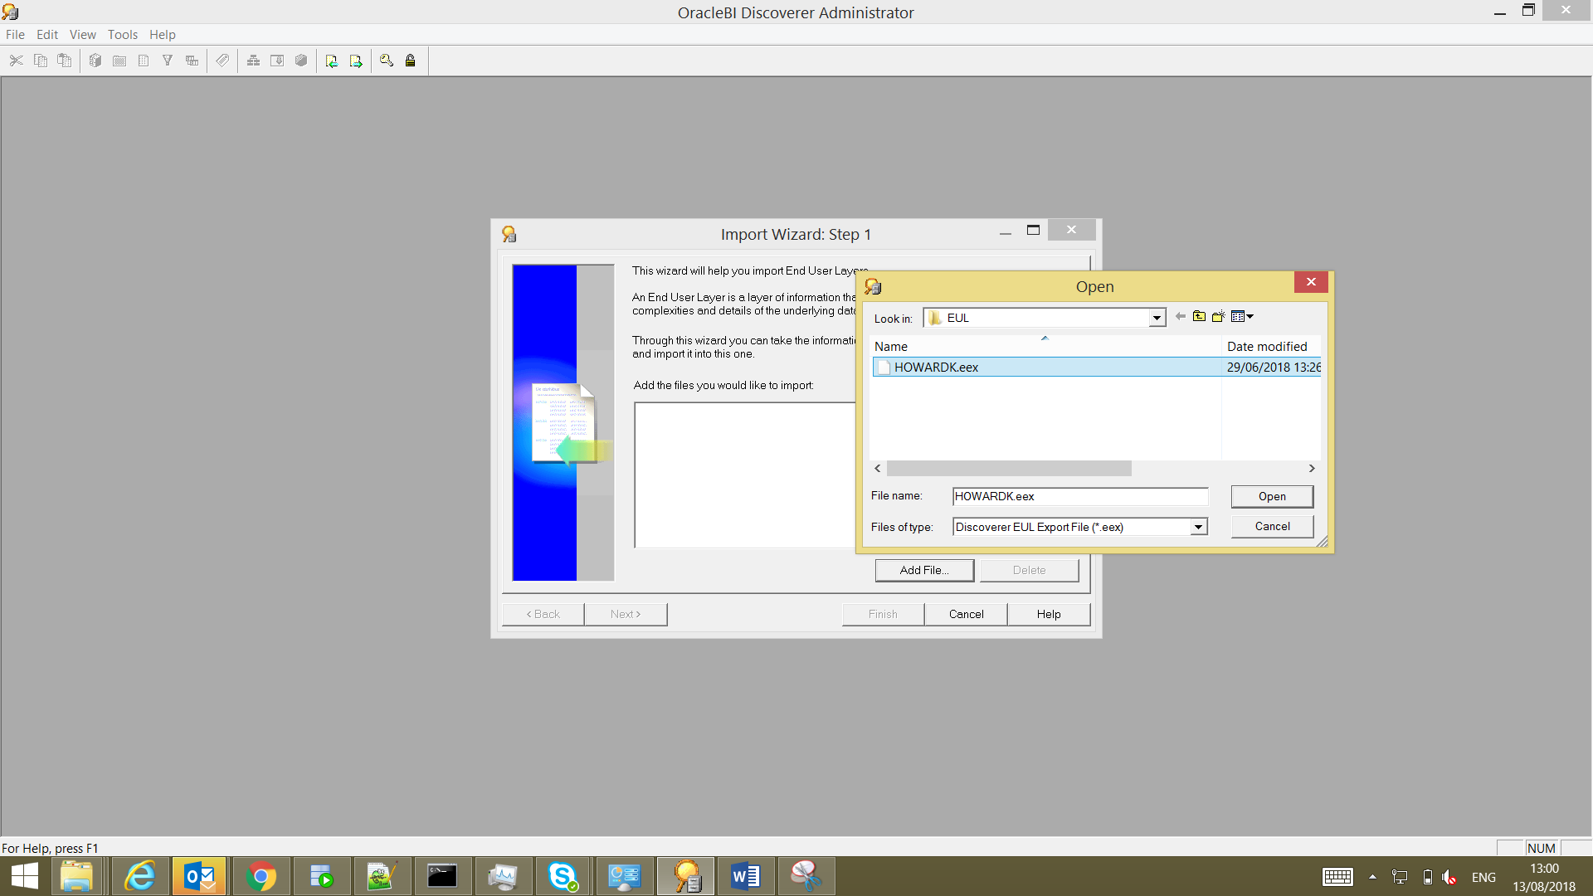

1. Click on next

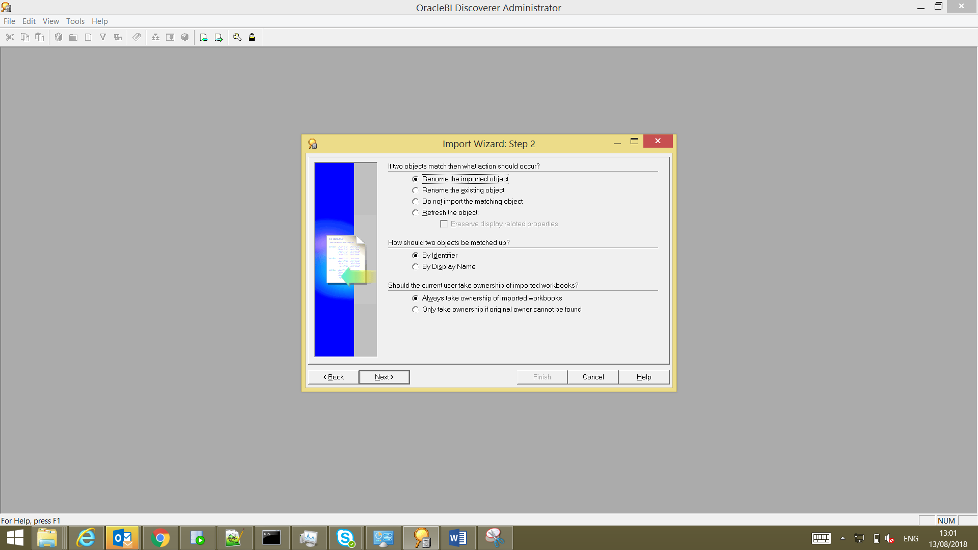

1. . Click on start button to Import EUL

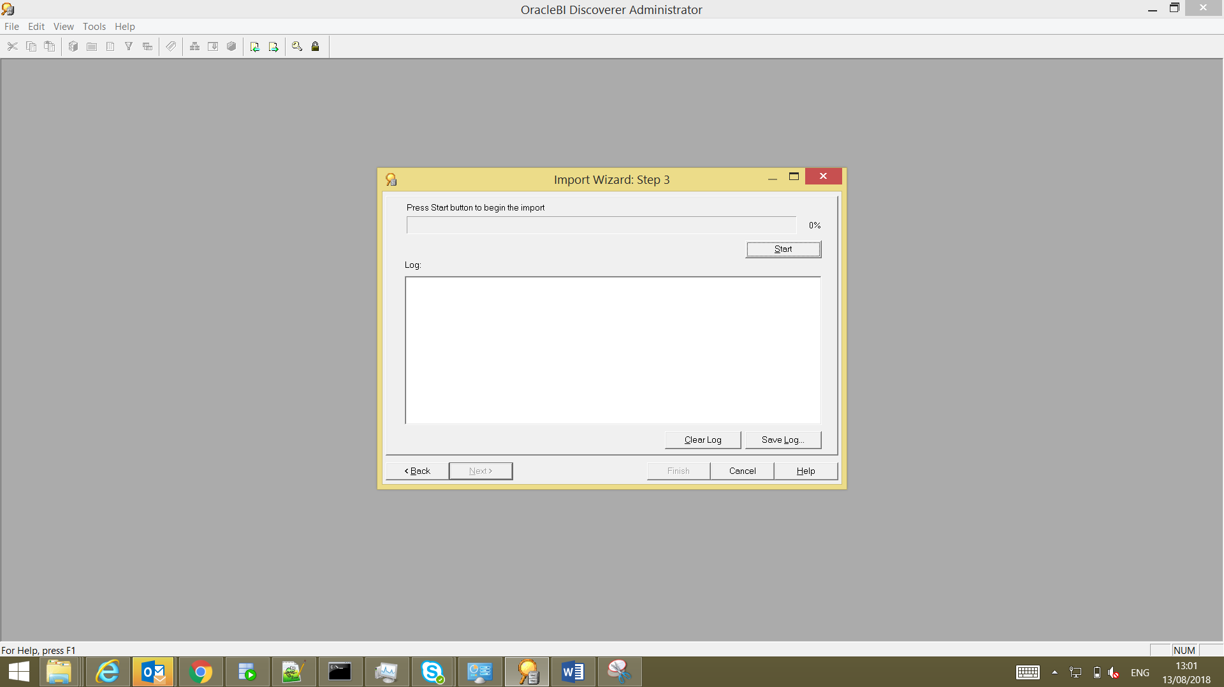

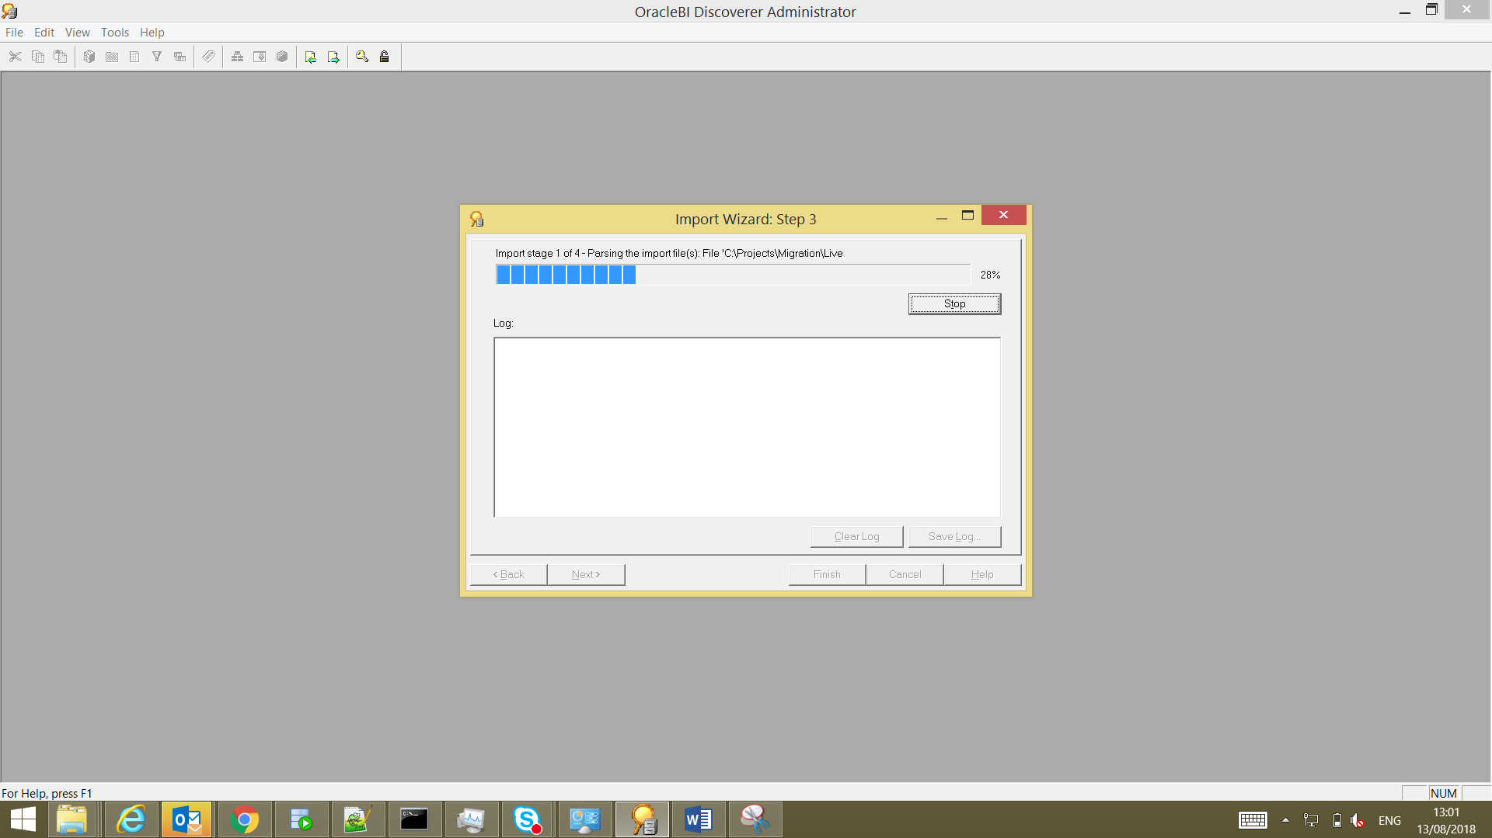

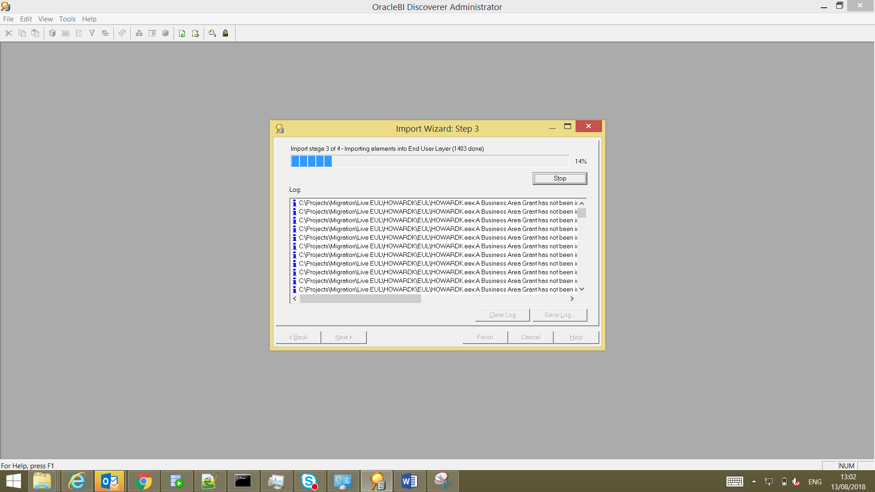

After Completion Save Log and click on finish

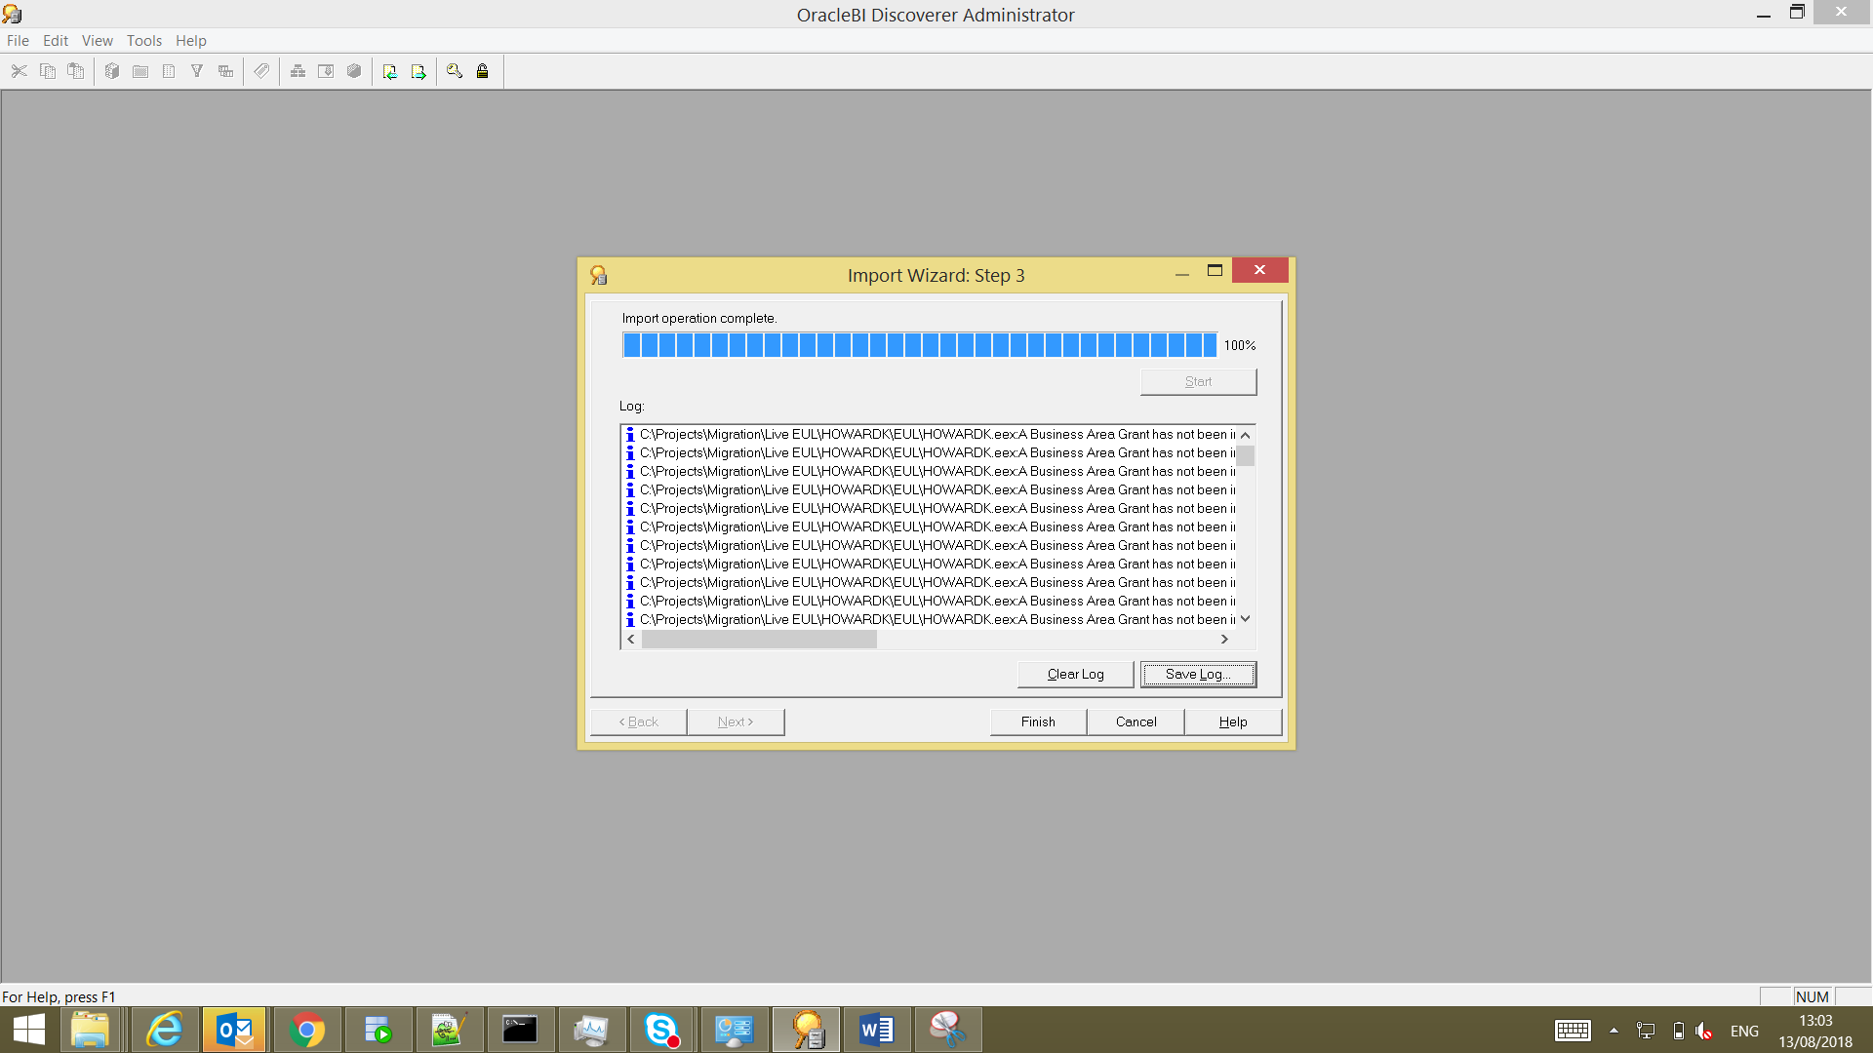

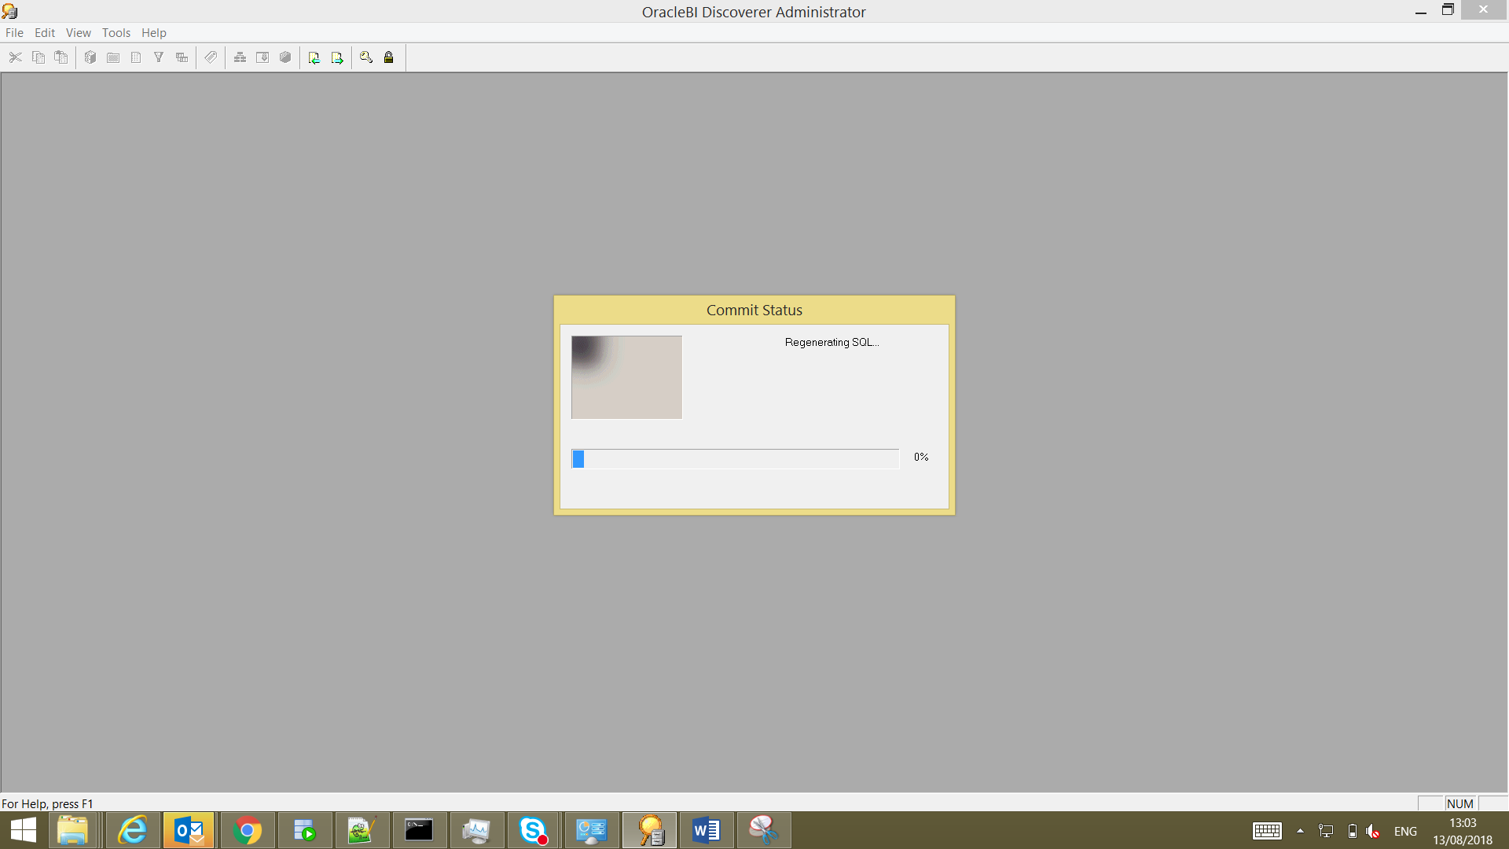

After commit we can see all business area’s in new user

Then log into database check all default tables are created or not

select distinct table_name from user_tab_columns ;

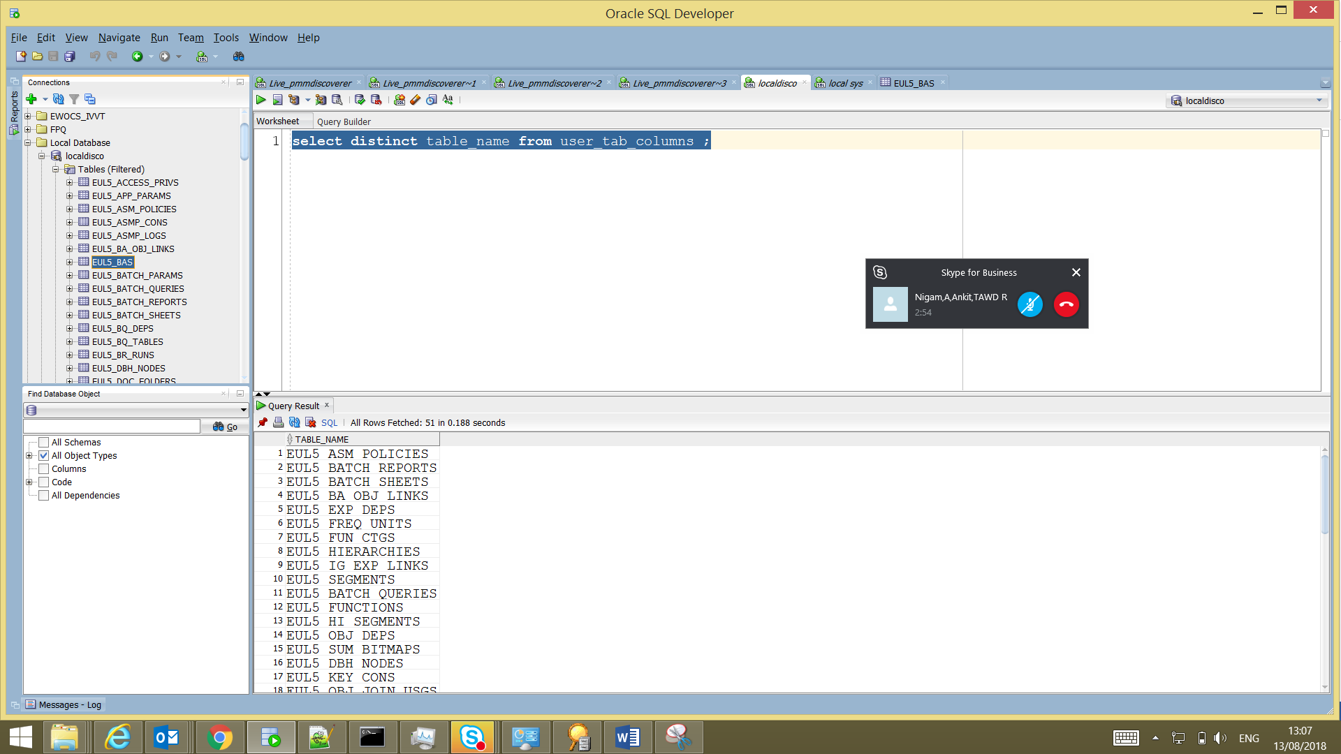

Now compare count of DB Objects like Tables, Views, Procedures, Functions Between New & Old User.